Requirement Analysis
Data Flow Diagram & User Stories
Date | November 2026
Student Name | Rachabathula Gnana Sruthi
Project Name | Automated Network Request Management
Maximum Marks

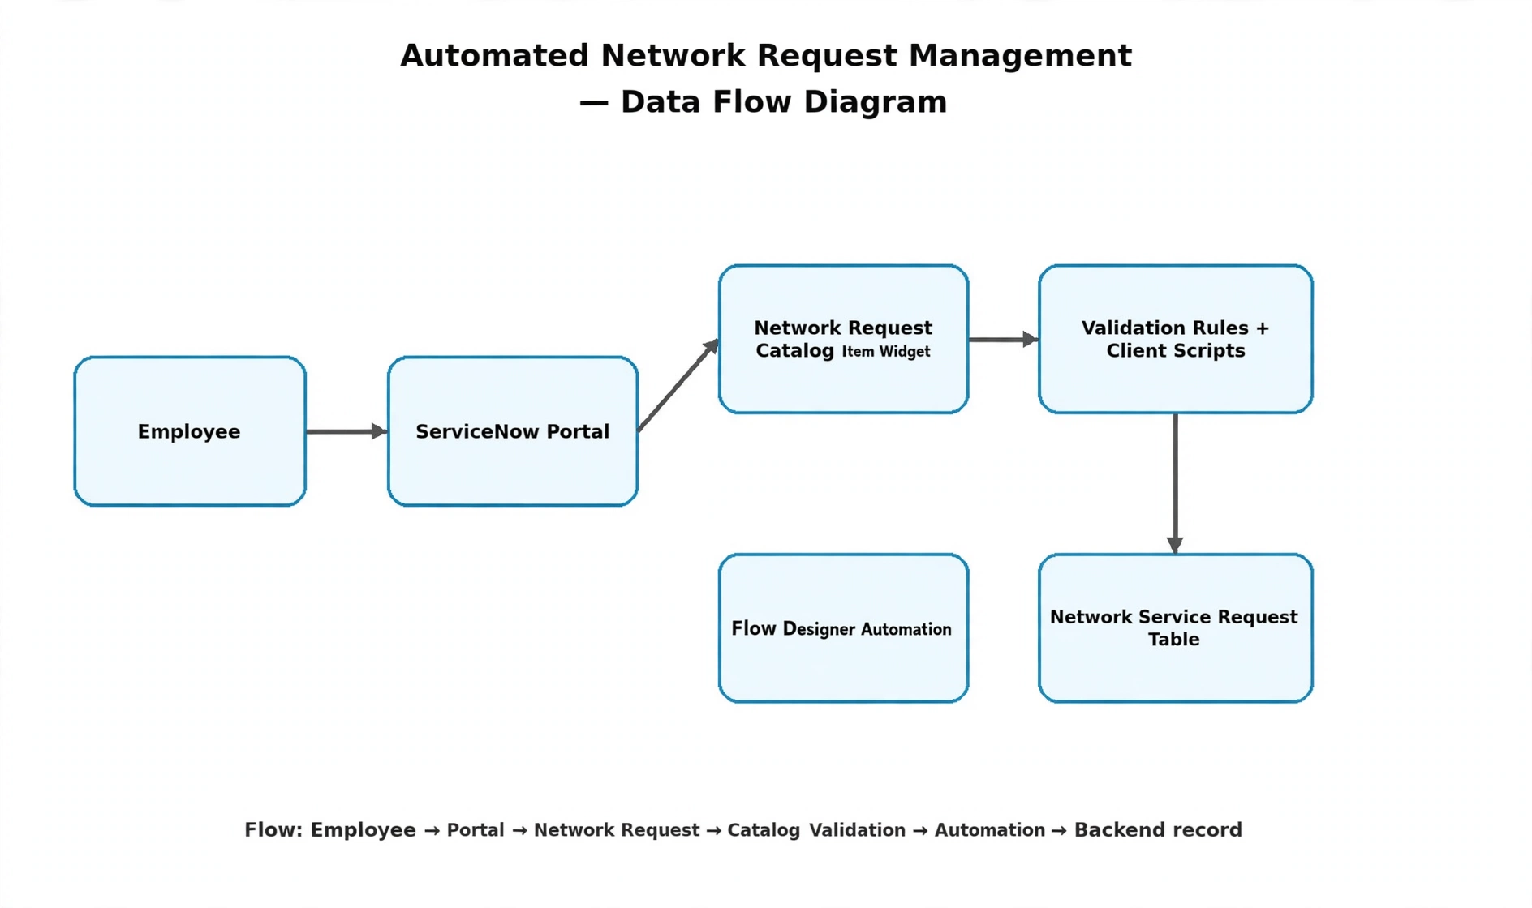
Logical Data Flow
Step | Flow
1 | Requester opens Service Portal (/sp).
2 | Selects Network Request catalog item widget.
3 | Widget redirects to Record Producer form.
4 | Requester enters network parameters (IP, port, device type, justification).
5 | Catalog UI Policies dynamically validate and toggle relevant fields.
6 | Record Producer creates backend record in custom table (u_network_requests).
7 | Flow Designer triggers approval routing and fulfillment tasks.
Figure 1: High-level Employee Raise Issue data flow
.
User Stories
User Type | User Story | Acceptance Criteria | Priority
Requester | Open portal and find Network Request catalog item. | Catalog item visible and accessible on /sp. | High
Requester | Enter network technical parameters and justification. | Form fields accept valid input data. | High
Requester | See dynamic fields appear based on request type. | UI Policies correctly toggle field visibility. | High
Requester | Submit network request form. | Backend record successfully created in custom table. | High
IT Manager | Receive automated approval request for network changes. | Flow Designer triggers approval task. | High
Network Engineer | Process approved fulfillment task and close request. | Task assignment and state updates function properly. | Medium

